CS331 Assignment #2 - Movies Database
Submission Report and Verification Document
Students: Jennifer Corte Juela and Arnav Kucheriya
This document summarizes the SQLite movies database, the schema design, the key and foreign-key constraints, the inserted data, and the SQL queries required by the assignment.
1. Assignment Summary
The database was created in SQLite using the four relations required by the prompt: Movie, Actor, StarsIn, and Studio. The database contains 20 movies, 19 actors, 6 studios, and 24 actor-to-movie relationships. The submitted SQL file contains the required .www line before every query so that the results open in separate browser tabs when the file is executed in SQLite.
- Database file: MOVIES.db
- SQL query file: MOVIES_queries.sql
- Resources cited in the SQL comment block include class notes and AI assistance used for drafting and formatting.
2. Relational Schema and Constraints
The schema below follows the structure requested in the assignment. Primary keys uniquely identify each row. Foreign keys enforce referential integrity between movies, studios, actors, and the StarsIn relationship table.
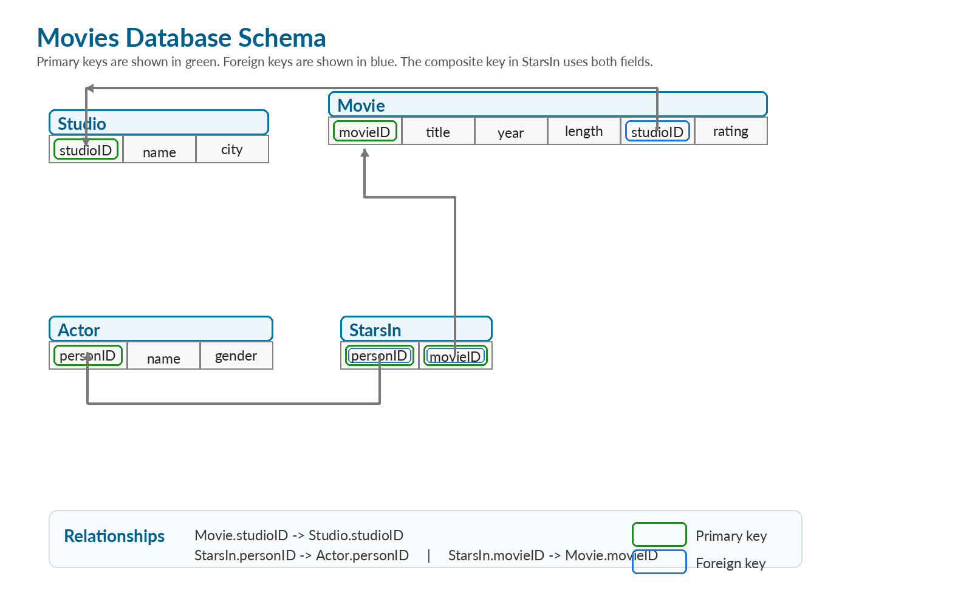
Relation | Attributes | Primary Key | Foreign Keys / Constraints
Studio | studioID, name, city | studioID | name and city are NOT NULL
Movie | movieID, title, year, length, studioID, rating | movieID | studioID references Studio(studioID); title is NOT NULL
Actor | personID, name, gender | personID | name is NOT NULL
StarsIn | personID, movieID | (personID, movieID) | personID references Actor(personID); movieID references Movie(movieID)
3. SQL Used to Create the Database
The following statements define the structure of the database and enforce the required keys and foreign keys.
CREATE TABLE Studio (
studioID INTEGER,
name TEXT NOT NULL,
city TEXT NOT NULL,
PRIMARY KEY (studioID)
);
CREATE TABLE Movie (
movieID INTEGER,
title TEXT NOT NULL,
year INTEGER,
length INTEGER,
studioID INTEGER,
rating REAL,
PRIMARY KEY (movieID),
FOREIGN KEY (studioID) REFERENCES Studio(studioID)
);
CREATE TABLE Actor (
personID INTEGER,
name TEXT NOT NULL,
gender CHAR,
PRIMARY KEY (personID)
);
CREATE TABLE StarsIn (
personID INTEGER,
movieID INTEGER,
PRIMARY KEY (personID, movieID),
FOREIGN KEY (personID) REFERENCES Actor(personID),
FOREIGN KEY (movieID) REFERENCES Movie(movieID)
);
4. Data Population Summary
The data was entered so that every required query returns a non-empty result. The selected movies include titles from MGM Studios, Star Wars films, several Leonardo DiCaprio films, and studios located in Los Angeles, which ensures that the query set in the assignment can be verified directly.
Table | Row Count | Purpose
Studio | 6 | Stores each production studio and city
Movie | 20 | Stores movie details including year, length, studio, and rating
Actor | 19 | Stores actor names and gender
StarsIn | 24 | Stores actor-movie relationships
5. Required SQL Queries Included in MOVIES_queries.sql
The SQL file begins with a block comment naming both students and listing the resources used. A line containing only .www appears before each query, matching the submission instructions in the assignment prompt.
- Q3. Movies produced by MGM Studios after 1990 with length greater than 90 minutes, ordered by decreasing length.
- Q4. All movies ordered by length from shortest to longest.
- Q5. All female actors in alphabetical order.
- Q6. Studio names that produced Star Wars movies, in alphabetical order.
- Q7. All movies starring Leonardo DiCaprio, with title, studio, rating, and year, ordered by year.
- Q8. Total movie length produced by each studio, in decreasing order.
- Q9. All studios located in Los Angeles, in alphabetical order.
- Q10. Average movie rating for each actor, in decreasing order of rating.
6. Query Verification Results
The following tables summarize the actual outputs produced by the current database content. These verification tables show that none of the required queries return an empty result.
Q3 Output
title
Skyfall
Creed

Q4 Output
title | length
Friday the 13th | 95
The Wizard of Oz | 102
Top Gun | 110
Star Wars: Episode IV - A New Hope | 121
Star Wars: Episode V - The Empire Strikes Back | 124
Jaws | 124
Iron Man | 126
Jurassic Park | 127
Superman | 129
Creed | 133
Skyfall | 143
Transformers | 144
Inception | 148
The Dark Knight | 152
Gladiator | 155
Interstellar | 169
The Godfather | 175
The Wolf of Wall Street | 180
Avengers: Endgame | 181
Titanic | 194

Q5 Output
name
Anne Hathaway
Betsy Palmer
Carrie Fisher
Connie Nielsen
Judy Garland
Kate Winslet
Laura Dern
Megan Fox
Scarlett Johansson

Q6 Output
name
Lucasfilm

Q7 Output
title | studio | rating | year
Titanic | Paramount Pictures | 8 | 1997
Inception | Warner Bros | 8.8 | 2010
The Wolf of Wall Street | Paramount Pictures | 8.2 | 2013

Q8 Output
name | total_length
Paramount Pictures | 898
Warner Bros | 598
Universal Pictures | 406
MGM Studios | 378
Marvel Studios | 307
Lucasfilm | 245

Q9 Output
name
MGM Studios
Marvel Studios
Paramount Pictures
Universal Pictures
Warner Bros

Q10 Output
name | average_rating
Marlon Brando | 9.2
Christian Bale | 9.1
Anne Hathaway | 8.7
Carrie Fisher | 8.65
Connie Nielsen | 8.5
Matthew McConaughey | 8.45
Scarlett Johansson | 8.4
Leonardo DiCaprio | 8.33
Laura Dern | 8.2
Robert Downey Jr. | 8.15
Roy Scheider | 8.1
Judy Garland | 8.1
Kate Winslet | 8
Daniel Craig | 7.8
Michael B. Jordan | 7.6
Megan Fox | 7.1
Tom Cruise | 7
David Corenswet | 7
Betsy Palmer | 6.4

7. Submission Checklist
- MOVIES.db opens correctly as an SQLite database.
- MOVIES_queries.sql contains the required comment block with both student names.
- The .www command appears before every query in MOVIES_queries.sql.
- The database includes at least 20 movies and related supporting data.
- All required queries return non-empty results.
8. Resource Citation Statement
Resources used in this solution: class notes, IMDb for movie and studio information, and AI tools used to help draft, format, and verify the final written materials and SQL presentation.

